[SprintOne] Design Document

October 10, 2019

Use this Requirements Specification template to document the requirements for your product or service, including priority and approval (Must do).

This document will also serve as a System Design Document (How to) and will include sections detailing system flow, algorithms, staffing plan, software/hardware, and Test Plan

This document contains instructions and examples which are for the benefit of the person writing the document and should be removed before the document is finalized.

To regenerate the TOC, select all (CTL-A) and press F9.

Table of Contents

1. Executive Summary 3

1.1 Project Overview 3

1.2 Purpose and Scope of this Specification 3

2. Product/Service Description 3

2.1 Product Context 3

2.2 User Characteristics 3

2.3 Assumptions 3

2.4 Constraints 3

2.5 Dependencies 4

3. Requirements 4

3.1 Functional Requirements 5

3.2 Security 5

3.2.1 Protection 5

3.2.2 Authorization and Authentication 6

3.3 Portability 6

4. Requirements Confirmation/Stakeholder sign-off 6

5. System Design 6

5.1 Algorithm 6

5.2 System Flow 6

5.3 Software 6

5.4 Hardware 6

5.5 Test Plan 7

5.6 Task List/Gantt Chart 7

5.7 Staffing Plan 7

# Executive Summary

## Project Overview

Our robot must be able to perform three different tasks. These tasks include moving around the room in a rectangle, move in a figure 8 five times and stop and the same spot and finally go through an obstacle course.

## Purpose and Scope of this Specification

The purpose of this is to show problem solving skills and the intended audience is our Professor, Gil Eckert.

# Product/Service Description

In order for the product to work you will want to have an open space with a flat floor for optimal performance.

## Product Context

This product is used with application on IOS and Windows Devices. You can use a Computer or even your smart phone to connect to the product.

## =============User Characteristics

This product would be very useful to children trying to get into computers at a young age, or even older students who are just trying to gain some knowledge about software engineering

## Assumptions

* Need a Sphero device
* No knowledge needed, could be very experienced

## Constraints

Some constraints could be battery life. If the robot is low on battery it will not receive your code as well. The rubber protection could also be a problem because each one is different. The Robot Must now be able to stay on course and stop at the correct point.

## Dependencies

The device will need the code to operate, you should also charge before use because it will result in the robot failing to receive code if it is running low on battery.

# Requirements

## Functional Requirements

In the example below, the requirement numbering has a scheme - BR_LR_0## (BR for Business Requirement, LR for Labor Relations). For small projects simply BR-## would suffice. Keep in mind that if no prefix is used, the traceability matrix may be difficult to create (e.g., no differentiation between '02' as a business requirement vs. a test case)

The following table is an example format for requirements. Choose whatever format works best for your project.

For Example:

| Req# | Requirement | Comments | Priority | Date Rvwd | SME Reviewed / Approved |
| --- | --- | --- | --- | --- | --- |
| RO_F8 | Ryan is going to program the robot the do a figure 8 | Business Process = “Maintenance | 3 | 7/13/04 | Bob Dylan, Mick Jagger |
| BR_LR_08 | The system should handle any number of fees (existing and new) associated with unions. | Business Process = “Changing Dues in the System”  An example of a new fee is an initiation fee. | 2 | 7/13/04 | Bob Dylan, Mick Jagger |
| BR_LR_10 | The system should capture and maintain job class status (i.e., active or inactive) | Business Process = “Maintenance”  Some job classes are old and are no longer used. However, they still need to be maintained for legal, contract and historical purposes. | 2 | 7/13/04 | Bob Dylan, Mick Jagger |
| BR_LR_16 | The system should assign the Supervisor Code based on the value in the Job Class table and additional criteria as specified by the clients. | April 2005 – New requirement. It is one of three new requirements from BR_LR_03. | 2 |  |  |
| BR_LR_18 | The system should provide the Labor Relations office with the ability to override the system-derived Bargaining Unit code and the Union Code for to-be-determined employee types, including hourly appointments. | April 2005 – New requirement. It is one of three new requirements from BR_LR_04.  5/11/2005 – Priority changed from 2 to 3. | ~~2~~  3 |  |  |

## Security

### Protection

The Sphero application will protect your code from other people if you want to keep it private under you account.

### Authorization and Authentication

In order to gain access to private code, you need to have the right username and password to access the account if the code is private.

## Portability

The system is able to be transported to different devices, even if they run on different operating systems. It will be able to be transported from and IOS device to a windows device with ease.

|  |  |  |
| --- | --- | --- |
| Meeting Date | Attendees (name and role) | Comments |
| 11/4 | Joe Von Dollen – Group Member  Ryan Trent – Group Member  Emilia B – Group Member | Tested our code |
|  | Bob Dylan, Labor Relations SME  Mick Jagger, Labor Relations SME  Ringo Starr, Technical Project Manager | Deferred / Deleted: BR_LR_01 - BR_LR_04, BR_LR_07, BR_LR_12, BR_LR_14, BR_LR_15, BR_LR_06, BR_LR_17 |

# System Design

This section will provide all details concerning the technical design, staffing, coding, and testing the system

## Algorithm

Steps

* Put robot on the X
* Flash Purple
* Stop For .5 seconds
* Loop 5 times
* Spin 358 degrees for 7.7 seconds
* Spin -358 degrees for 7.7 seconds
* Stop
* Delay for 2 seconds
* Speak “Im the winner” and wait
* Flash Random Colors

## stem Flow



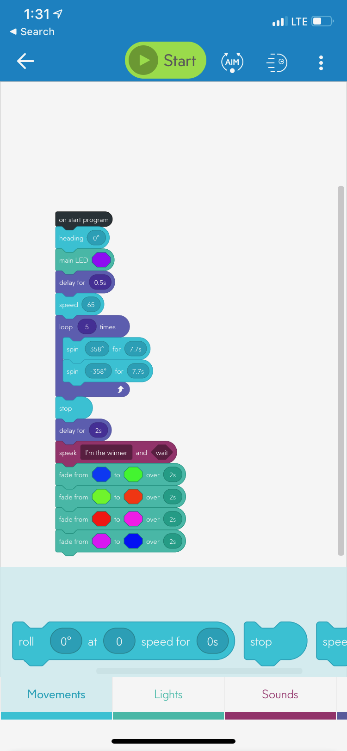

## Software

The software language that is used is already given in the app, just input the speed and degrees of turning.

## Hardware

What we used for our project was our iPhone and computers.

## Test Plan

| **Reason for Test Case** | **Test Date** | **Expected Output** | **Observed Output** | **Staff Name** | **Pass/Fail** |
| --- | --- | --- | --- | --- | --- |
| Tried To make the robot move in a circle | 11/6 | The robot will move in a circle and stop at the “x” | The robot spun off course | Joe, Ryan, Emilia | Fail |
| We changed the degrees of spinning to make the robot stay on course | 11/6 | The robot is going to stop at the “x’ while staying on path | The robot moved in the circle and stayed on path but stopped further than the “x” | Joe, Ryan, Emilia | Fail |
| We shortened the time the robot moved while increasing the speed to make it stop at the “x” | 11/7 | The robot is going to stop at the “x” | The robot stayed on path and stopped at the “x” | Joe, Ryan, Emilia | Pass |
| Now instead of having the robot stop at the “x” we copied the degrees and speed and reversed the circle to complete the figure 8 than stop at the “x” | 11/7 | The robot stays on course and completed the figure 8 and then stopped at the “x” | The robot stayed on course and was able to stop at the “x’ | Joe, Ryan, Emilia | Pass |
| We tried doing the figure 8 five times in a row | 11/7 | The robot stays on course for a figure 8 | The robot completed the figure 8 five times | Joe, Emilia | pass |
|  |  |  |  |  |  |
|  |  |  |  |  |  |
|  |  |  |  |  |  |

## Task List/Gantt Chart

Task List

* Staffing Plan

Joe 11/3

* Algorithm (DONE)

Ryan 11/3

* Flow Chart (DONE)

Amelia 11/4

* Code (DONE)

Ryan and Joe 11/6

* Test Plan (DONE)

Joe Amelia 11/7

* Design Document (DONE)

Joe Amelia Ryan 11/3-7

## Staffing Plan

Insert a chart/table that depicts the roles and responsibilities of each team member that worked on this project

| **Name** | **Role** | **Responsibility** | **Reports To** |
| --- | --- | --- | --- |
| **Joe** | Group Member | Gantt chart | Ryan |
| **Ryan** | Group Member | Task list | Amelia |
| **Amelia** | Group Member | Code | Joe |